________________________________________________________________

PROJECT REPORT
ON
ONLINE EXAMINATION SYSTEM
__________________________________

INDEX
Contents
1. Project Objectives 3
2. Description of the project 4
3 Project Management Methodology 6
4 Requirement Gathering and Analysis 8
4.1 Technologies to be used 8
4.2 Minimum Software Requirement 8
4.3 Software Environment 8
4.4 Minimum Hardware Requirement 8
4.5 Hardware Environment 8
4.6 Technology description 9
4.7 Structure of the project 10
5. System Design 13
5.1 Use Case Diagram 13
5.2 Flow chart of system 14
5.3 Entity Relationship Diagram 17
5.4 Data Flow Diagram 19
5.5 Database Design 22
7. User Interface 26
8. Future Scope of System 36
9. Bibliography 36

Project Objectives

The objective of this document is to develop Online Examination System website. Online examination represents an examination system through internet. Candidate appearing for examination will be provided with a computer and examination is to be conducted through an internet browser in the presence of invigilator without needing to install any special software.
System focuses on reducing the hectic job of manually assessing the answers of candidates. Candidates and examiner will have to create an account on the system after which an examination can be setup. A candidate will be provided with multiple choice questions during the examination. Responses will be checked by system automatically and result will be displayed only when examiner wants to do so.
Because the whole process is automated, therefore reducing the paperwork to large extent. System will generate its examination assessment reports and display to examiner and candidates whenever allowed by examiner.
Another important objective of developing such system is to eliminate searching from another source on computer such as internet and avoid cheating from other candidate at examination time. This objective is to be achieved by detecting if examination interface loses its focus.
Users of the system i.e. examiner and candidate belongs to Educational Institutes like schools, universities and training centres etc.
Additionally, following objectives have been kept in mind:
- Practicality – The system should be quite practical and user friendly.
- Availability – System should be available 24/7.
- Reliability – System should have high degree of fault tolerance. It should be able to recover from hardware failures, power failures etc.
- Usability – Navigation through the web interface should be easy to navigate.
- Integrity – The system should be secure and must us encryption to protect the databases. Users must be authenticated before they can access personal data.

Description of the project

  - Project Perspective
Online examination system is a web based application. This system is particularly suited for conducting objective examinations in Universities, Colleges, Institutes, Schools. The system will save valuable time in answer books and the results can be obtained immediately. System offers the following:
  - Fully automated web based examination software.
  - Register examiners and candidates online.
  - Provide examiners the facility of creating and managing examinations.
  - Provide facility for candidates to appear in examination.
  - Provide security for authenticating candidates appearing in examination.
  - Provide facility to examiner to suspend the result of a candidate in required situation.
  - Provide examiners and candidates the results of examination immediately after examination.
  - To store previous results and providing facility to view previous results.
A brief description of how the system works:
  - Examiner registers an account on the system and create examinations.
  - Candidate register an account on the system.
  - Examiner start the examination and provides a password for the examination. An examination ID is issued to the examiner.
  - Candidate login to their account and appear in the examination by providing examination ID, examination password and candidate roll number.
  - Candidates are asked random question to avoid cheating.
  - After the completion of examination, examiner and candidates are provided with the result of examination.
2.2 Product Features
  - Globally accessible application
  - Specific exam format
  - Exams can be edited, deleted and re-used anytime.
  - Result can be viewed and printed anytime.
2.3 User Characteristics
Examiner should have knowledge of creating online account, creating examinations. Candidates need the knowledge of creating online account, appearing in online examination. Overall users of the system need not to have very high technical knowledge. The system is user friendly.
2.4 Operating Environment
The software will be a web based application, meaning it runs from a browser. Product should be run from a remote client machine with an internet connection.
  - Design and Implementation Characteristics
  - Medium of instruction will be English only.
  - The internet connection of the organization should be fast enough to navigate through system.
2.6 User Documentation
  - General instructions will be provided to the examiner and candidates.
  - Examiner may provide additional instructions to the candidates.

Project Management Methodology

The Project Management Methodology used for the project is SDLC-Waterfall Model.
The software development life cycle (SDLC) is a framework defining tasks performed at each step in the software development process. SDLC is a structure followed by a development team within the software organization. It consists of a detailed plan describing how to develop, maintain and replace specific software. The life cycle defines a methodology for improving the quality of software and the overall development process.
The Waterfall Model was the first Process Model to be introduced. It is also referred to as a linear-sequential life cycle model. It is very simple to understand and use. In a waterfall model, each phase must be completed before the next phase can begin and there is no overlapping in the phases.
The waterfall Model illustrates the software development process in a linear sequential flow. This means that any phase in the development process begins only if the previous phase is complete. In this waterfall model, the phases do not overlap.
Waterfall Model - Design

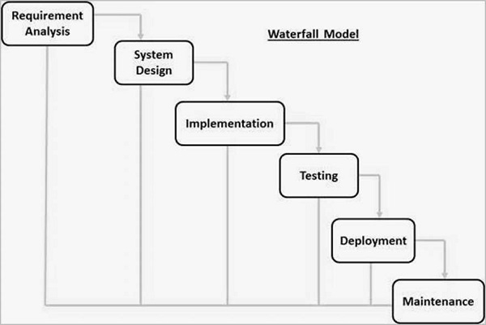

The sequential phases in Waterfall model are −
Requirement Gathering and analysis − All possible requirements of the system to be developed are captured in this phase and documented in a requirement specification document.
System Design − The requirement specifications from first phase are studied in this phase and the system design is prepared. This system design helps in specifying hardware and system requirements and helps in defining the overall system architecture.
Implementation − With inputs from the system design, the system is first developed in small programs called units, which are integrated in the next phase. Each unit is developed and tested for its functionality, which is referred to as Unit Testing.
Integration and Testing − All the units developed in the implementation phase are integrated into a system after testing of each unit. Post integration the entire system is tested for any faults and failures.
Deployment of system − Once the functional and non-functional testing is done; the product is deployed in the customer environment or released into the market.
Maintenance − There are some issues which come up in the client environment. To fix those issues, patches are released. Also to enhance the product some better versions are released. Maintenance is done to deliver these changes in the customer environment.

Requirement Gathering and Analysis

4.1 Technologies to be used
  - XAMPP Server
  - PHP (Server Side Scripting)
  - MariaDB Server (Database Design)
  - jQuery (Client Side Scripting)
  - HTML (Interface Design)
  - CSS (Style Scripting)

4.2 Minimum Software Requirement
  - Windows 7 or higher or equivalent OS
  - Server – XAMPP or IIS or Apache Server
  - Platform - NetBeans IDE with PHP plugin
  - Server Scripting - PHP 5
  - Database – MariaDB Server
  - Internet Browser – Internet browser with JavaScript support

4.3 Software Environment
  - OS - Windows 10 64bit
  - Server – XAMPP v3.2.2
  - Platform – NetBeans IDE with PHP plugin
  - Server Scripting - PHP 7.1.11
  - Database – MariaDB Server 10.1.36
  - Internet Browser - Google Chrome, Mozilla Firefox, Microsoft Edge

4.4 Minimum Hardware Requirement
  - Processor: Pentium IV 2.0 and above
  - RAM: 1 GB
  - Disk space: 4GB

4.5 Hardware Environment
  - I3 Processor
  - 4 GB RAM
  - 1 TB Hard Disk

4.6 Technology description

- XAMPP (Cross Platform + Apache + MariaDB + PHP + Perl) Server - XAMPP is a free and open-source cross-platform web server solution stack package developed by Apache Friends, consisting mainly of the Apache HTTP Server, MariaDB database, and interpreters for scripts written in the PHP and Perl programming languages. Since most actual web server deployments use the same components as XAMPP, it makes transitioning from a local test server to a live server possible.
- PHP (PHP: Hypertext Pre-processor) - PHP is a server scripting language, and a powerful tool for making dynamic and interactive Web pages. PHP is a widely-used, free, and efficient alternative to competitors such as Microsoft's ASP.
- MariaDB Server - MariaDB is a community-developed fork of the MySQL relational database management system intended to remain free under the GNU GPL. Development is led by some of the original developers of MySQL, who forked it due to concerns over its acquisition by Oracle Corporation. Contributors are required to share their copyright with the MariaDB Foundation.
- jQuery - jQuery is a cross-platform JavaScript library designed to simplify the client-side scripting of HTML. It is free, open-source software using the permissive MIT License.
- HTML – Hypertext Markup Language is the standard markup language for creating web pages and web applications. With Cascading Style Sheets and JavaScript, it forms a triad of cornerstone technologies for the World Wide Web.
- CSS - Cascading Style Sheets is a style sheet language used for describing the presentation of a document written in a markup language.
- NetBeans - NetBeans is a software development platform written in Java. The NetBeans Platform allows applications to be developed from a set of modular software components called modules. Applications based on the NetBeans Platform, including the NetBeans integrated development environment (IDE), can be extended by third party developers. The NetBeans IDE is primarily intended for development in Java, but also supports other languages, in particular PHP, C/C++ and HTML5.

4.7 Structure of the project

candidate-login
examiner-login
candidate-signup

candidate-dashboard
examiner-signup

examiner-dashboard
index
examiner-dashboard
candidate-dashboard
candidate-edit-profile-details
candidate-active-exams
candidate-results
candidate-instructions
examiner-edit-profile-details

examiner-active-exams

examiner-question-banks
candidate-new-exam
examiner-exams

examiner-results

examiner-instructions

candidate-about
examiner-about

Details:
- Index: Homepage of the website
- Examiner-login: Login page for examiner with registration link.
- Examiner-dashboard: Dashboard after login of examiner containing links to other pages.
- Examiner-signup: Registration form for examiner
- Examiner-edit-profile-details: Editing of profile details by examiner excluding email address.
- Examiner-question-banks: Page for management of questions.
- Examiner-exams: Page for management of examinations.
- Examiner-results: Page for viewing results of candidates.
- Examiner-instructions: General instructions page for examiner.
- Examiner-about: General information about the website.
- Candidate-login: Login page for candidate containing link for registration and password recovery.
- Candidate-dashboard: Page for management of candidate.
- Candidate-signup: Registration form for candidate.
- Candidate-edit-profile-details: Editing of profile details by candidate excluding email address.
- Candidate-active-exams: Links to active exams.
- Candidate-new-exam: Page for joining ongoing exam.
- Candidate-results: Page for viewing results of the examination.
- Candidate-instructions: General instructions for the candidate.
- Candidate-about: General information about the website.
- Style1: Styling for larger screens.
- Style2: Styling for smaller screens.
- Header: Header part of page.
- Footer: Footer part of page.

System Design

5.1 Use Case Diagram

A use case diagram at its simplest is a representation of a user's interaction with the system that shows the relationship between the user and the different use cases in which the user is involved. A use case diagram can identify the different types of users of a system and the different use cases and will often be accompanied by other types of diagrams as well.

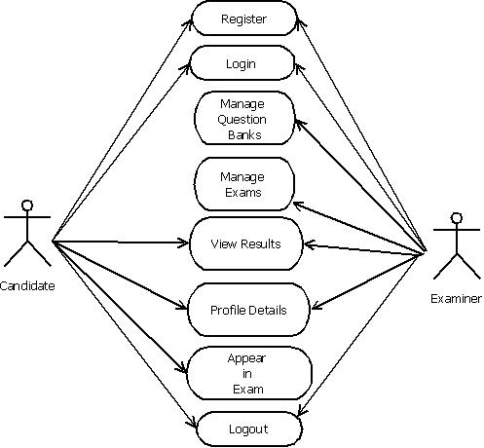

5.2 Flow chart of system

Flowcharts are used in designing and documenting simple processes or programs. Like other types of diagrams, they help visualize what is going on and thereby help understand a process, and perhaps also find flaws, bottlenecks, and other less-obvious features within it.

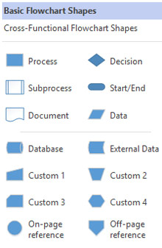

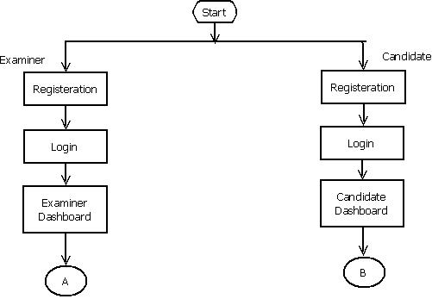

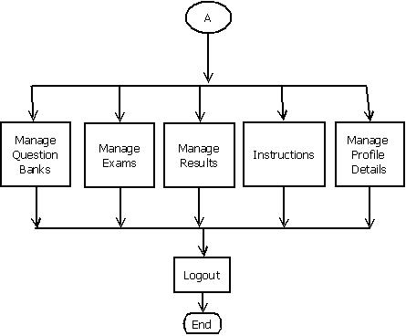

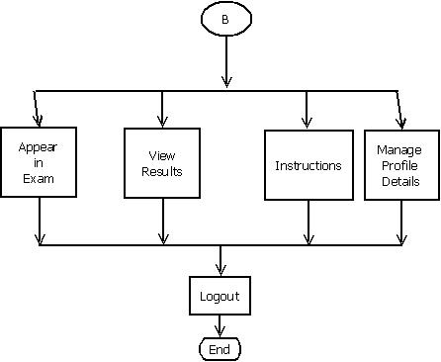

5.3 Entity Relationship Diagram

An entity–relationship model (ER model) describes inter-related things of interest in a specific domain of knowledge. An ER model is composed of entity types (which classify the things of interest) and specifies relationships that can exist between instances of those entity types.

Entity:
Entities are represented by means of rectangles. Rectangles are named with the entity set they represent.

Attributes:
Attributes are the properties of entities. Attributes are represented by means of ellipses. Every ellipse represents one attribute and is directly connected to its entity (rectangle).

Relationship:
Relationships are represented by diamond-shaped box. Name of the relationship is written inside the diamond-box. All the entities (rectangles) participating in a relationship, are connected to it by a line.

One-to-one − When only one instance of an entity is associated with the relationship, it is marked as '1:1'. The following image reflects that only one instance of each entity should be associated with the relationship. It depicts one-to-one relationship.
One-to-many − When more than one instance of an entity is associated with a relationship, it is marked as '1:N'. The following image reflects that only one instance of entity on the left and more than one instance of an entity on the right can be associated with the relationship. It depicts one-to-many relationship.
Many-to-one − When more than one instance of entity is associated with the relationship, it is marked as 'N:1'. The following image reflects that more than one instance of an entity on the left and only one instance of an entity on the right can be associated with the relationship. It depicts many-to-one relationship.
Many-to-many − The following image reflects that more than one instance of an entity on the left and more than one instance of an entity on the right can be associated with the relationship. It depicts many-to-many relationship.

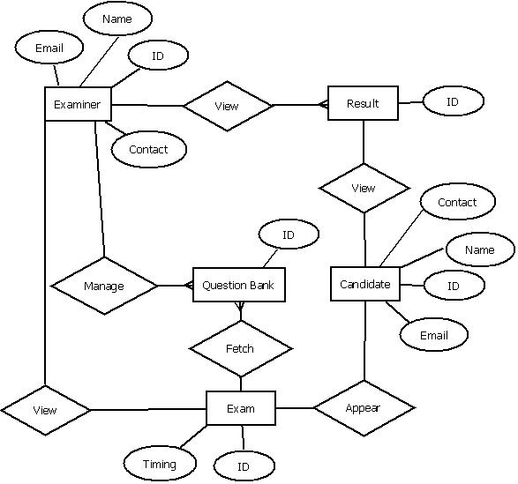

Data Flow Diagram

A Data Flow Diagram (DFD) is a graphical representation of the "flow" of data through an information system. A DFD is often used as a preliminary step to create an overview of the system. DFDs can also be used for the visualization of data processing (structured design).
A DFD shows what kind of information will be input to and output from the system, where the data will come from and go to, and where the data will be stored. It does not show information about the timing of process or information about whether processes will operate in sequence or in parallel.

Data flow diagram Symbols:
- External entities: rectangular box

- Data flow: arrow headed lines

- Process/ function: bubble/ circle.

- Data store: narrow opened rectangle or one side open rectangle

A data flow diagram represents the following:
- External devices sending or receiving data.
- Processes that change the data.
- Data flow themselves.
- Data storage locations.

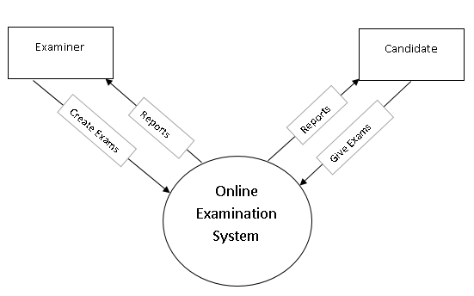

Level-0 DFD

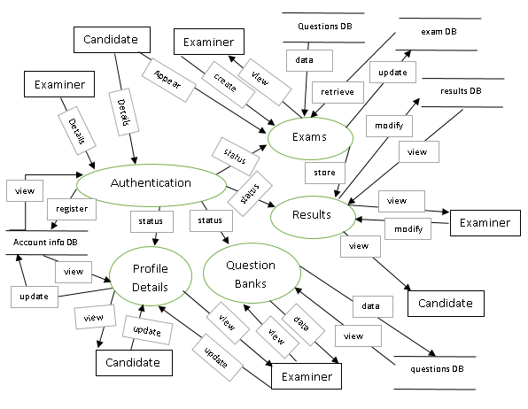
Level-1 DFD

Database Design

Database: mydb_exam1
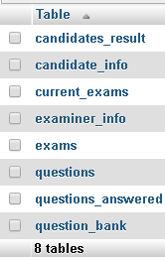

Table: candidates_result
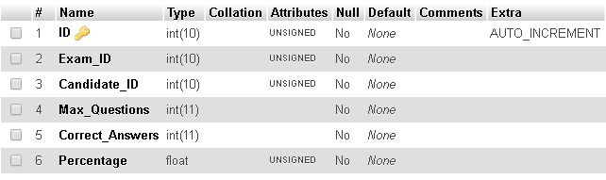

Table: candidate_info
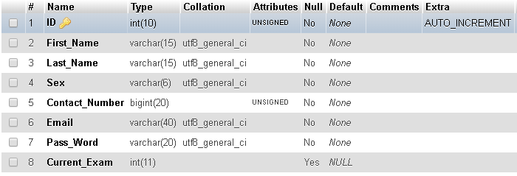

Table: current_exams
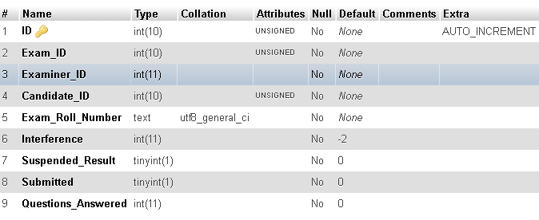

Table: examiner_info
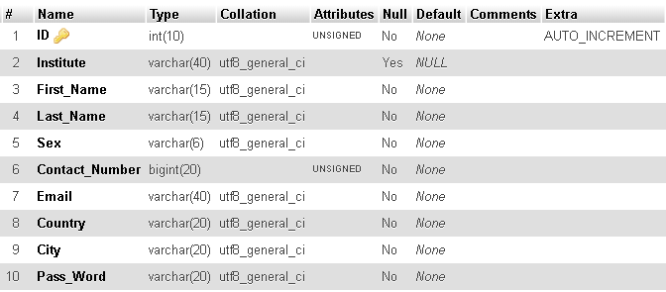

Table: exams
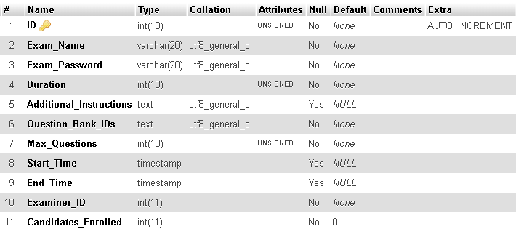
Table: questions
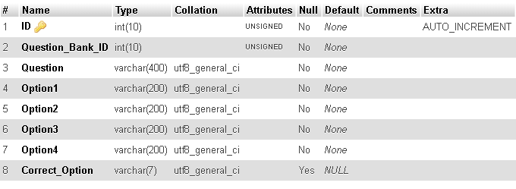

Table: questions_answered
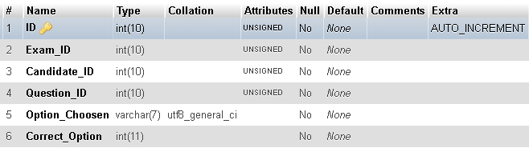

Table: question_bank
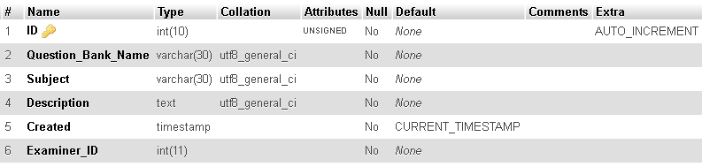

7. User Interface
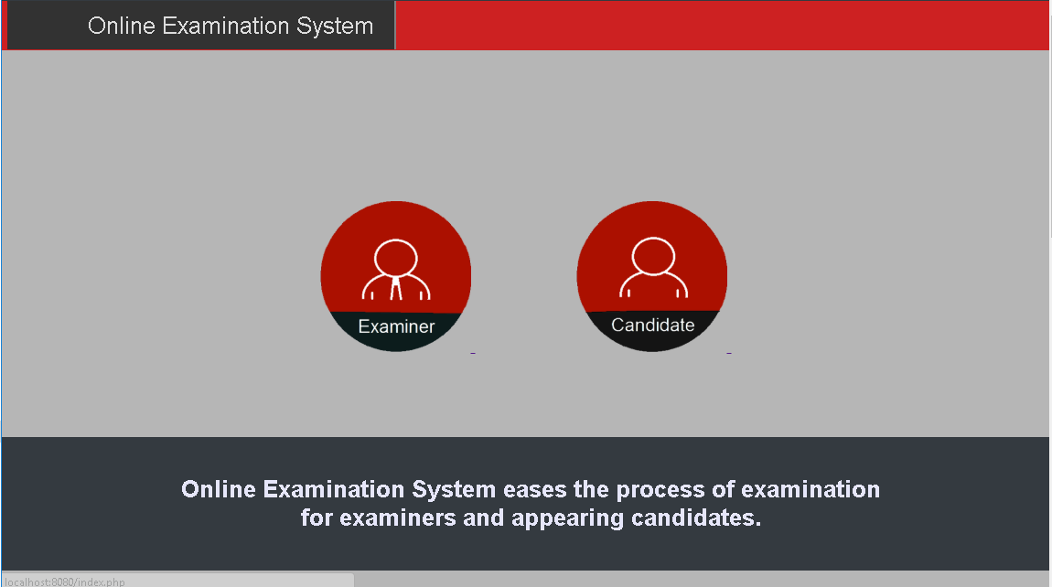

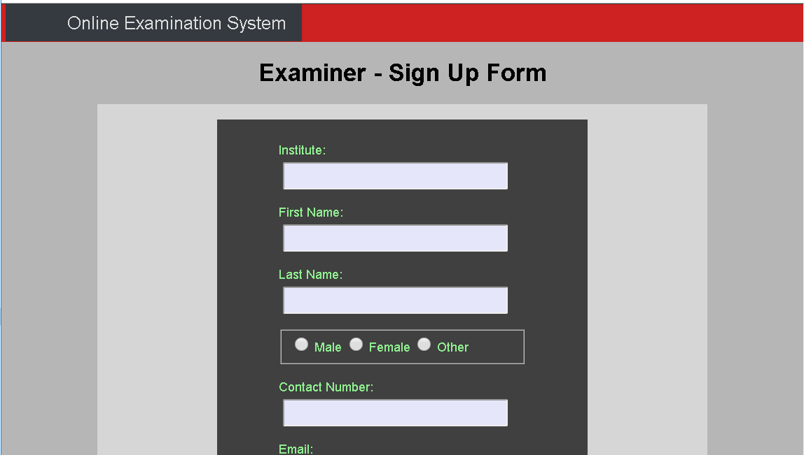
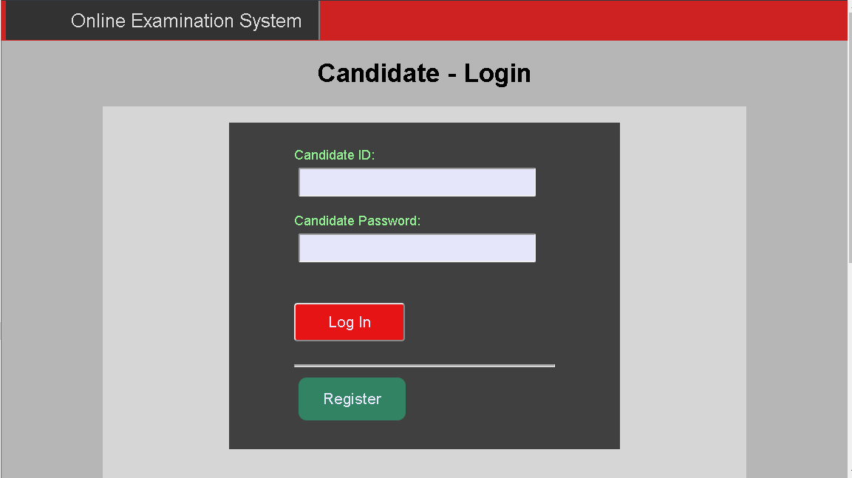

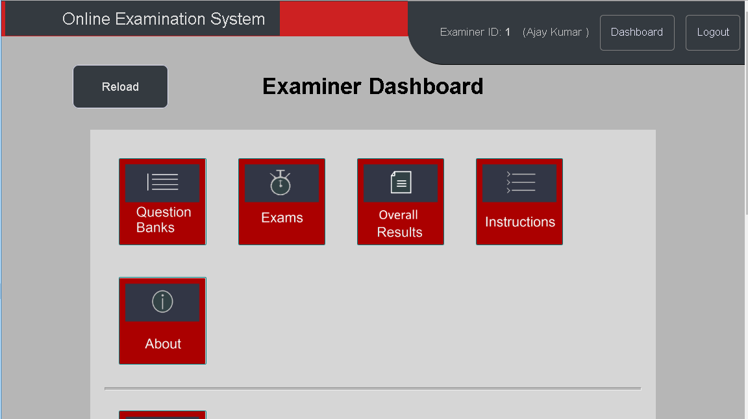
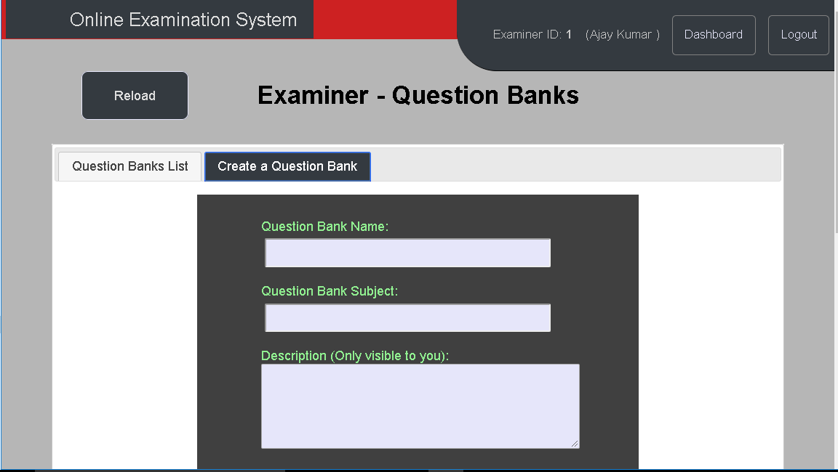

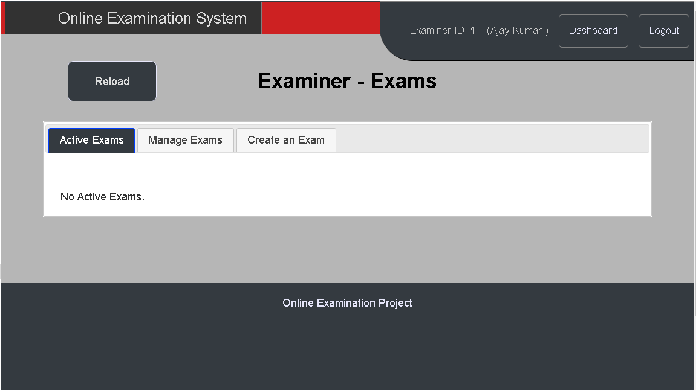
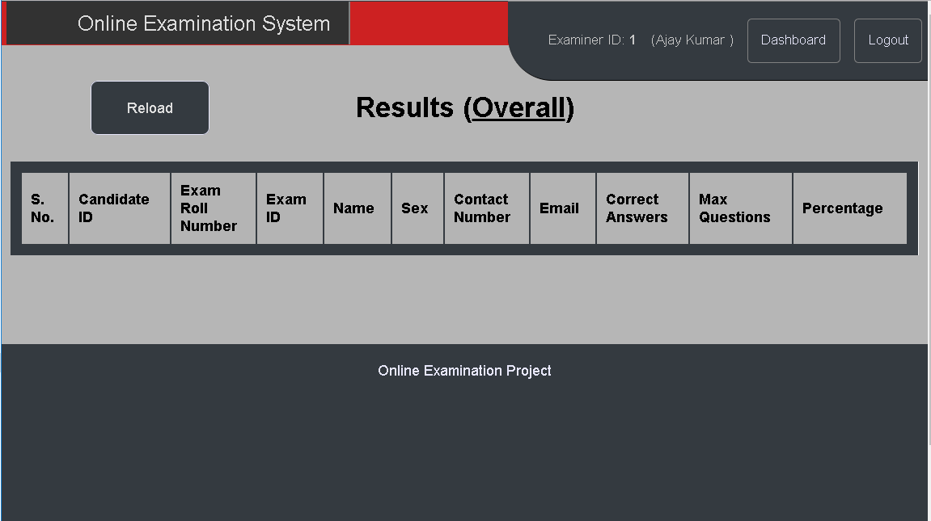

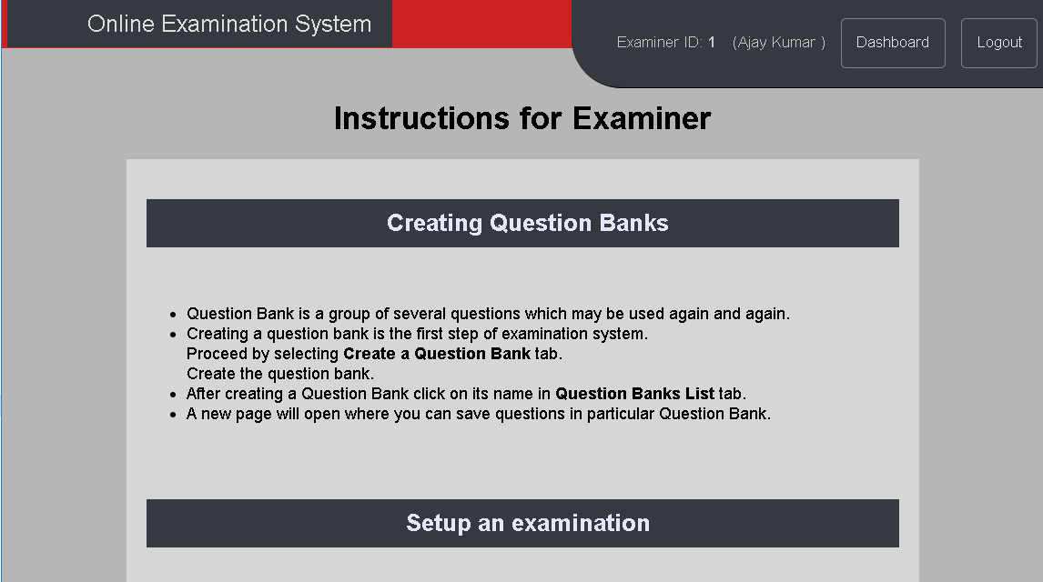
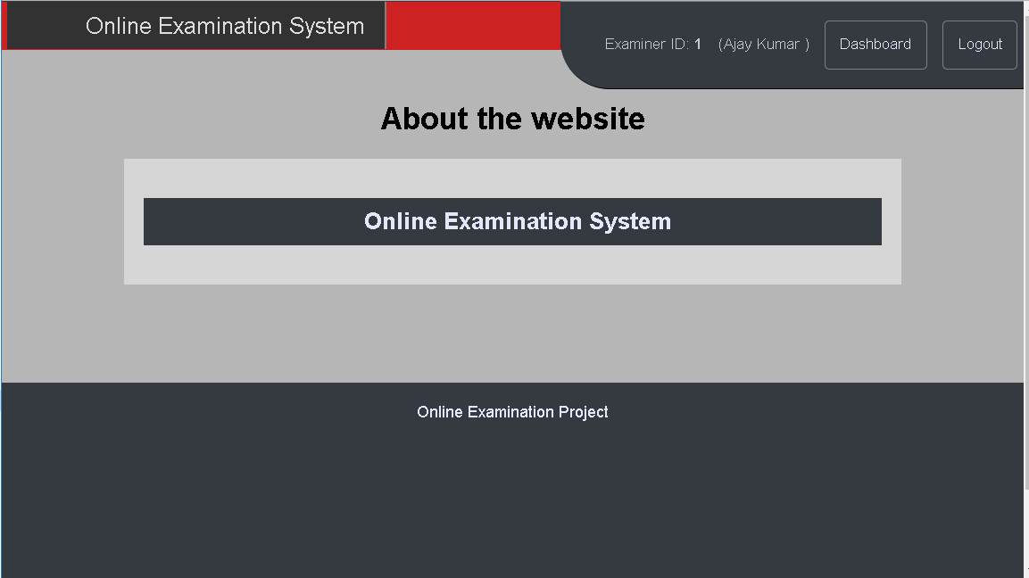

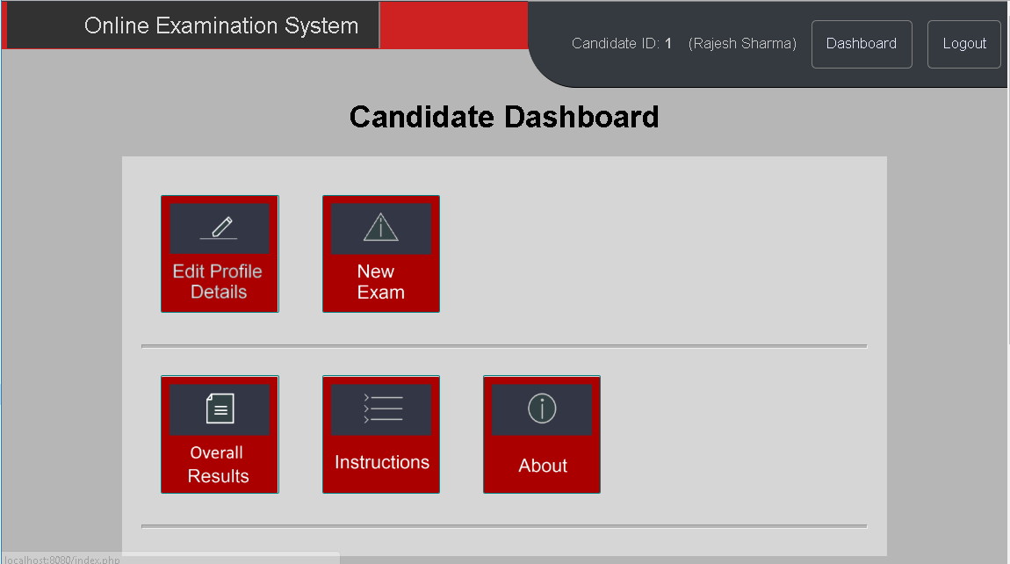
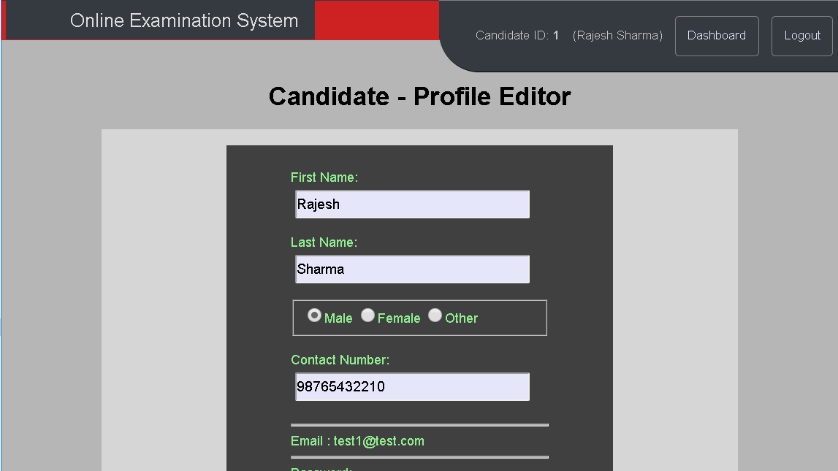

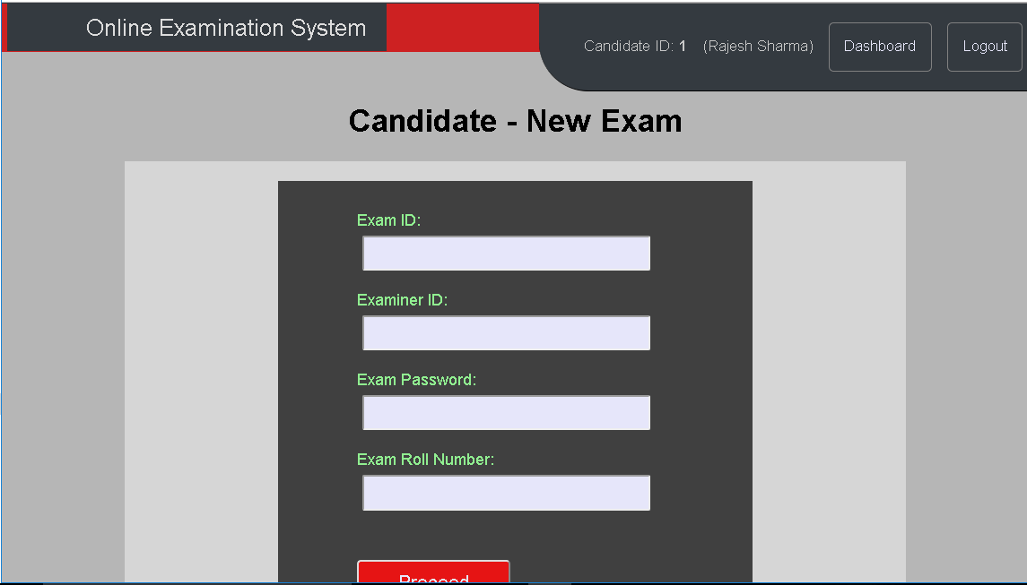
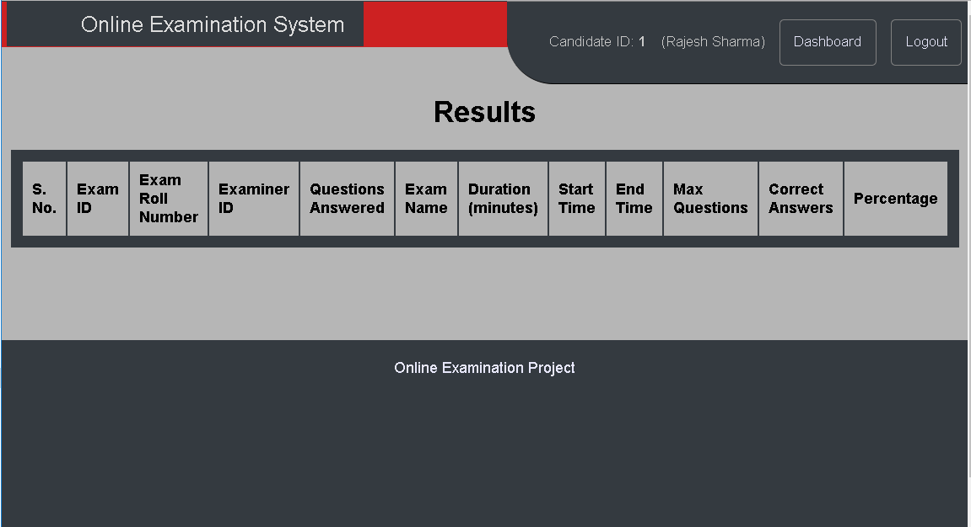

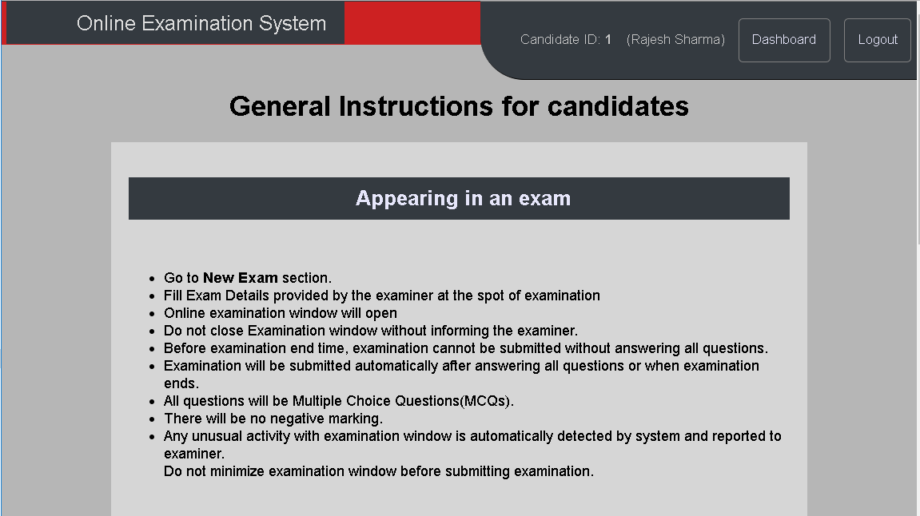
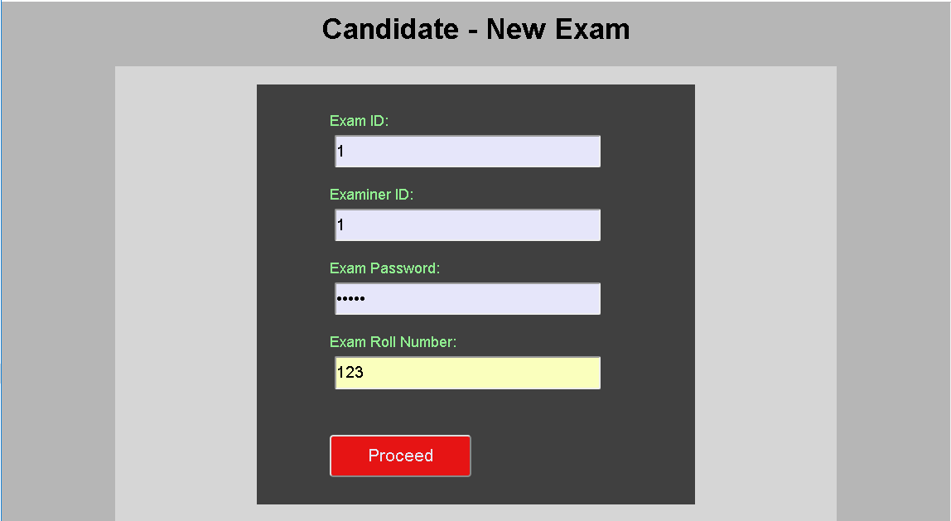

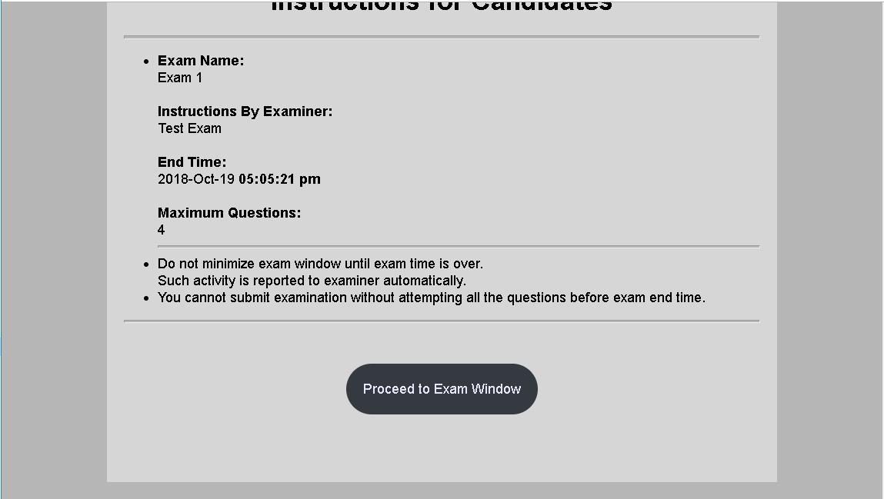
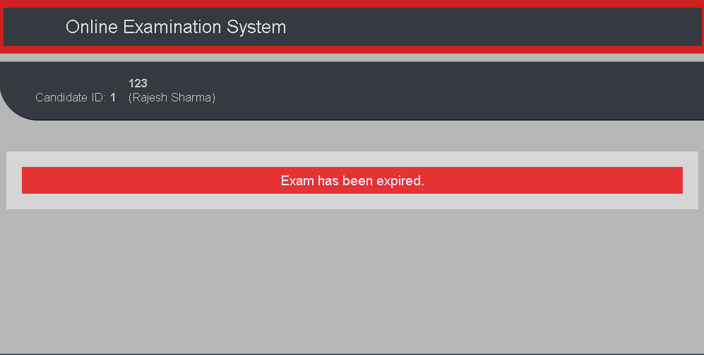

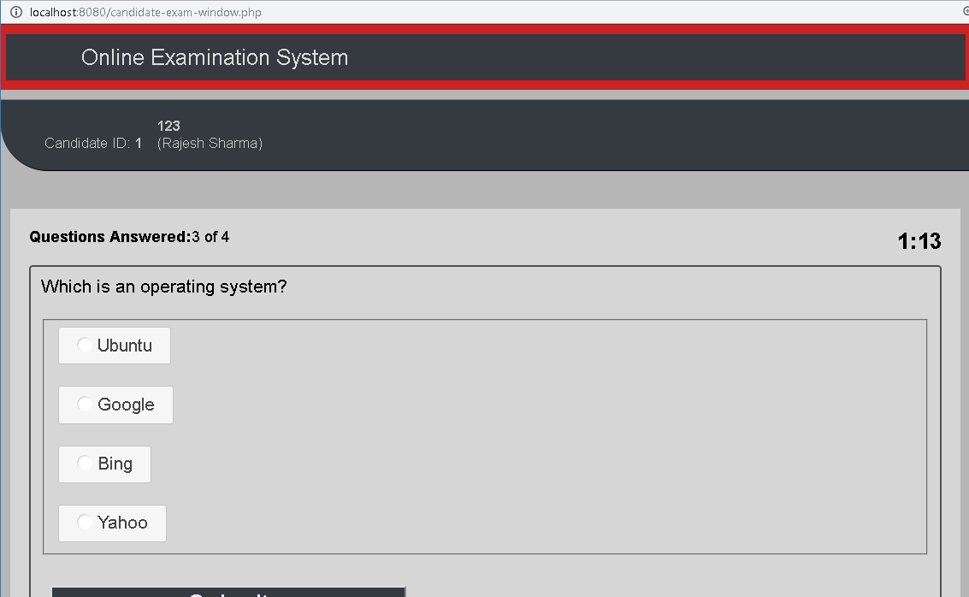
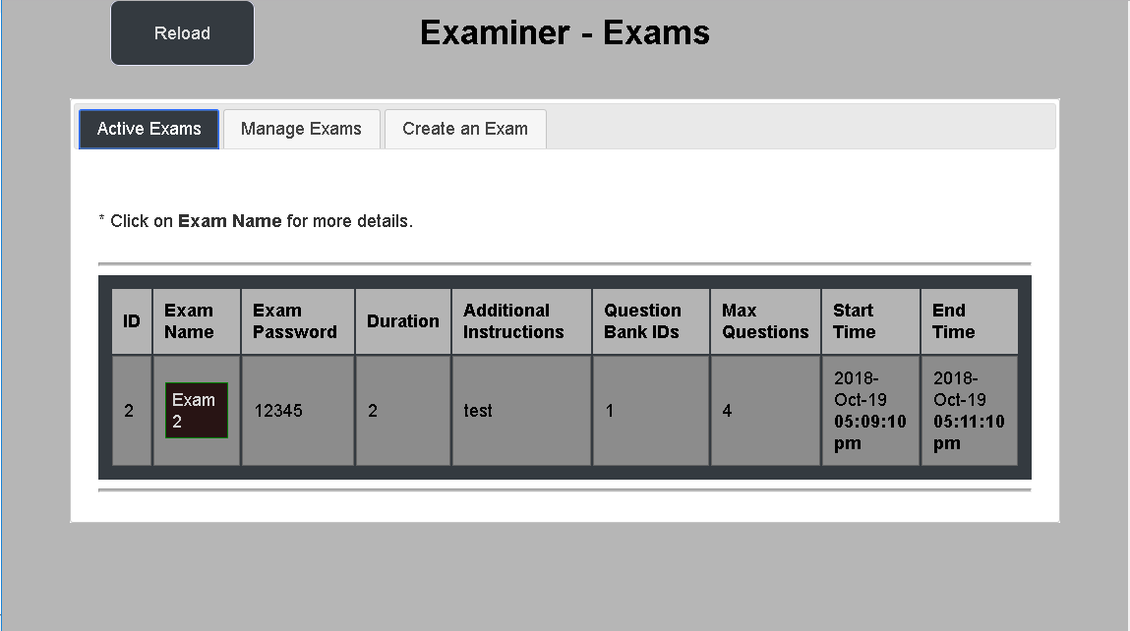

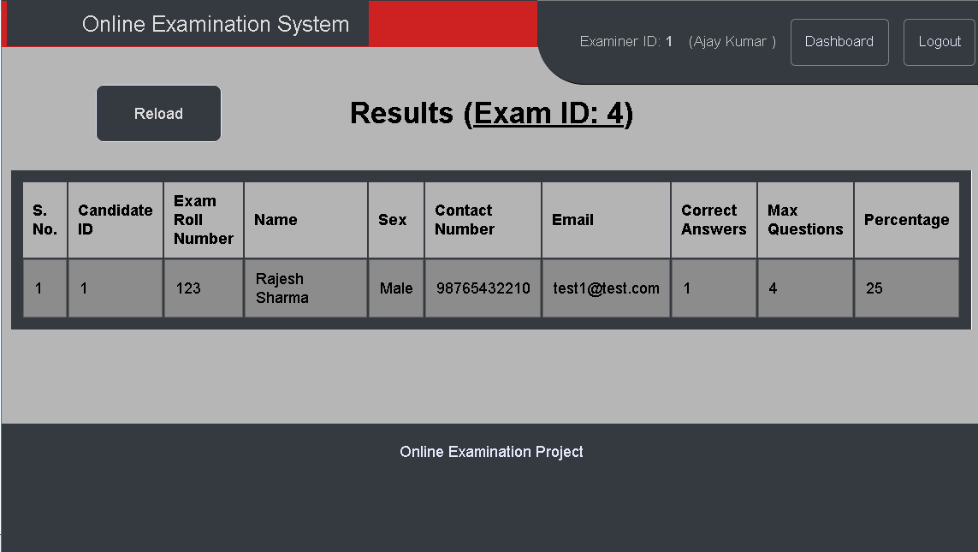

8. Future Scope of System
Future updates can be added to the website, such as maintaining user preferences and customizing dashboard according to the requirement of user. Institute logos can be integrated for customization according to the need of institutes. Verification for a particular institute can be added to verify an institute.

9. Bibliography

www.youtube.com
www.en.wikipedia.org
www.slideshare.net
www.scribd.net
www.w3schools.com
www.tutorialspoint.com

